11. AMALIY ISHI
Mavzu: Urlconnection asosida tarmoq dasturini yaratish

Ishning maqsadi:
URL bu Uniform Resource Locators, ya’ni bu har bir sahifaning nomidir.
Har bir site nomi hech yerda qaytarilmaydi va boshqa joyda ishlatilmaydi. Bu qaytarilmas sahifa nomidir. Misol uchun http://www.mail.uz faqatgina bittadir, boshqa hech qayerda shu nomli site ochilishi mumkin emasdir, va ochilmaydi ham.
URL to’rt qismdan iboratdir.
Protocol://ServerName:PortNumber/FileName
Protocol: bu http protokolidir.
ServerName: mail.uz
PortNumber: 80, agarda hech narsa yozilmagan bo’lsa bu avtomatik ravishda 80 portdir.
FileName: Ko’pincha ko’rsatilmaydi, serverning ishlashiga bog’liqdir.

Topshiriq:
Talaba Amaliy ishi uchun shaxsiy topshiriq oladi. Bu topshiriq bo‘yicha talaba Urlconnection asosida tarmoq dasturini yaratadi. Har bir talaba uchun shaxsiy topshiriq berilgan.

Nazariy qism:
Veb sahifabir nechta obyektlardan tashkil topadi. Obyekt URL tomonidan addresslangan bo`lib, u HTML fayl, JPEG rasm, Java applet yoki video klip ko`rinishida bo`lishi mumkin.Ko`plab Veb sahifalar HTML fayllar bazasidan va manbalarga ega bir nechta obyektlardan tashkil topgan. Masalan, Veb sahifa HTML matnva 5 ta JPEG rasmdan tashkil topgan bo`lsa, shunda u jami 6 ta obyektga ega bo`ladi. HTML fayl bazasi sahifadagi qolgan obyektlarni obyektlarning URL orqali manbalaydi. Har bir URL 2 ta komponentga ega: serverning host nomi va obyektning yo`li nomi. Masalan, quyidagi URL:
http://www.someSchool.edu/someDepartment/picture.gif
bunda www.someSchool.edu host nomi va /someDepartment/picture.gif esa yo`l nomi.Vebbrauzerlar HTTP ning klient tomonini ifodalagani uchun biz teng ma`noli brauzervaklient so`zlarini ishlatishimiz mumkin. Veb serverlar o`z navbatida HTTP ning server tomonini ifodalaydi. Mashhur Veb serverlarga misol tariqasida Apache va Microsoft Internet Information serverlarini keltirish mumkin.
Intеrnеt xizmatlarining ko’pchiligiga dostup (ruxsat, yo’l) adrеsatsiya sxеmasi (URL) yordamida qiziqtirilgan ixtiyoriy hujjatni topish imkoniyatini bеradi. Har bir tur boshqasidan farq qiluvchi o’zining format adrеsiga ega.
Boshqa tomondan Intal kompaniyasining wеb-sahifasini yuklash uchun wеb-brauzеrning adrеslar panеliga www.mail.ru ni yozishi kеrak.
Shunday qilib URL bu – so’ralayotgan hujjatning aniq adrеsini ko’rsatish imkoniyatini bеrish uchun www.mail.ru kabi adrеslar turlari kombinatsiyasi va yana qo’shimcha elеmеntlarga ega. URL day foydalanib, wеb-brauzеrlar yordamida ixtiyoriy hujjat va xizmatlarga dostup olish mumkin. URL quyidagi tartibda yoziladi:
Protokol://intеrnеt_adrеs /yo’l /fayl_nomi.kеngaytma yoki Protokol://intеrnеt_adrеs URL ga misol: http://www.microsoft.com/windows/index.html
Bu еrda: http:// – protokol;
www.microsoft.com – intеrnеt_adrеs (Microsoft kompaniyasinnig wеb- sеrvеrinnig nomi)
/windows/ – yo’l
index – fayl_nomi
html – kеngaytma
URL da qo’llaniladigan protokollar. URL da qo’llaniladigan protokollar ro’yxati:
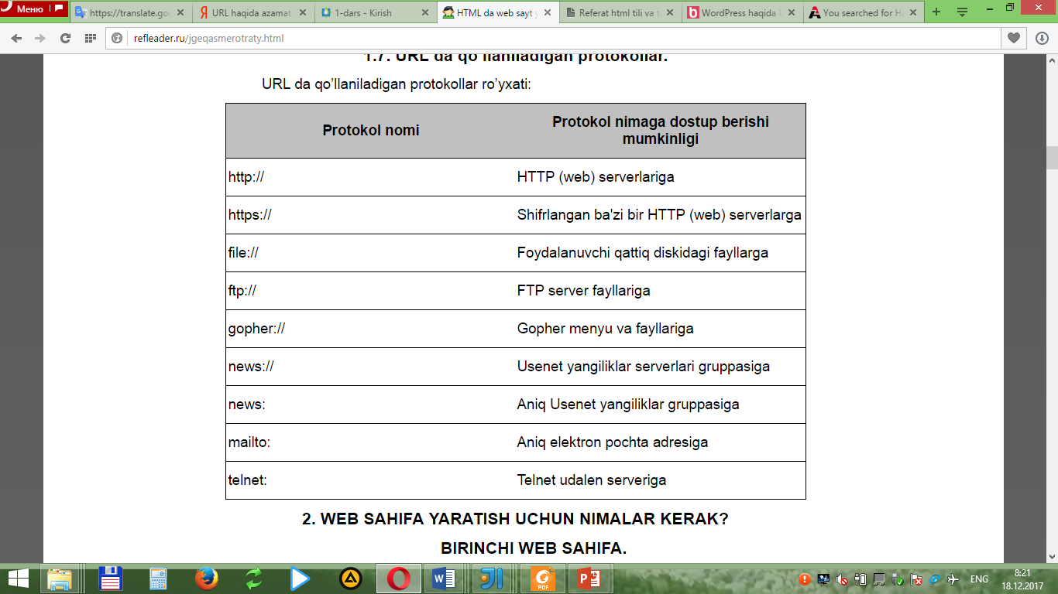

HTTP protokoli Vebklientlar Veb serverlardan Veb sahifalarni qanday so`rashlarini va serverlar klientlarga Veb sahifalarni qanday yuborishlarini ifodalaydi. 2.6 rasmda HTTP ning so`rov-javob yuborishlari keltirilgan. Foydalanuvchi Vebsahifani so`raganida, brauzer sahifadagi obyekt uchun HTTP so`rov xabarini serverga yuboradi. Server so`rovni qabul qiladi va HTTP javob xabari orqali so`ralgan obyektlarni taqdim etadi.

Ishni bajarish tartibi:
IntellijIdea interfeysida Java dasturlash tilidan foydalanib URLConnection tizimini ishlab chiqamiz. Buning uchun dastlab IntellijIdea dasturini ishga tushiramiz. Yangi dastur yaratish uchun New Project funksiyasini File buyruqlar panelidan topamiz.
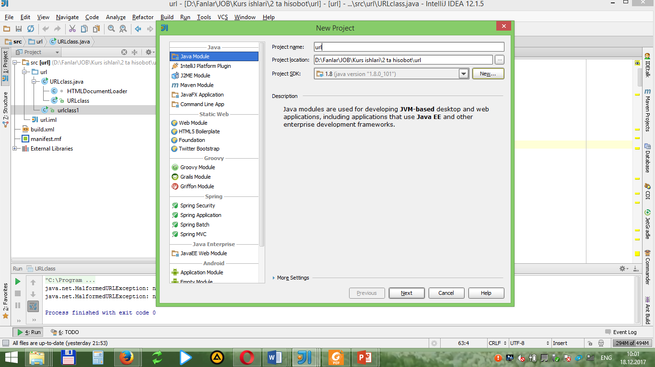
Unga yangi “url” degan package yaratamiz:
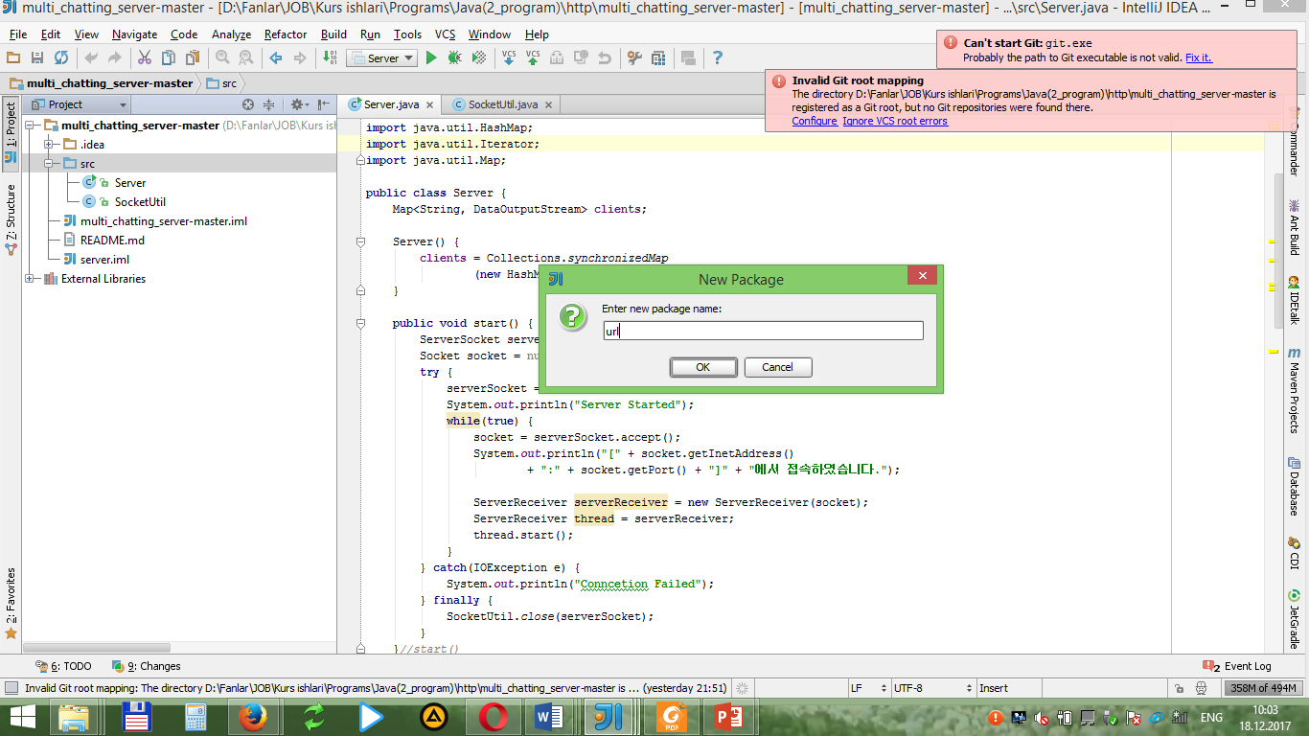
So’ngra, url package ga “URLclass” degan klas yaratamiz:
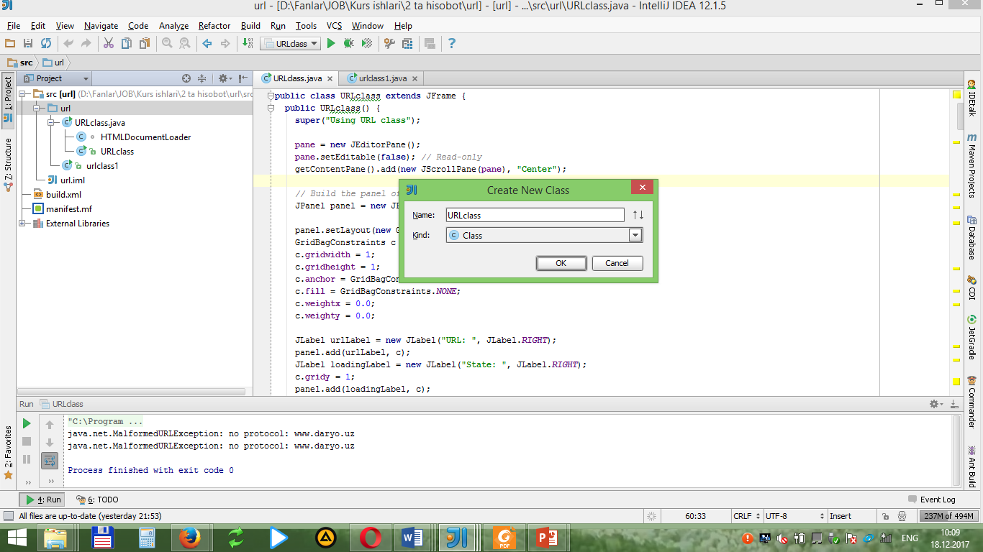

So’ngra, url package ga “URLclass” degan klas yaratamiz:
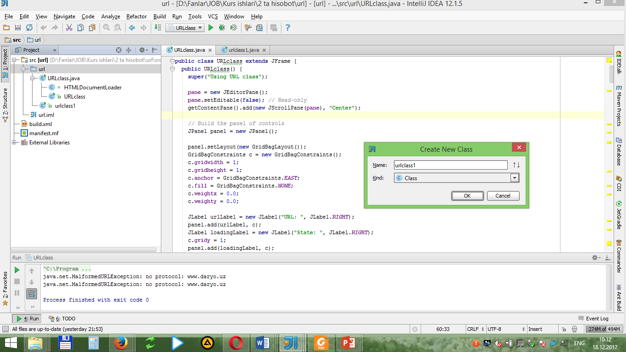

Undan so’ng esa, mavjud ikkita klaslarga UrlConnection ni ta’miinlash uchun unga quyidagi kodlarni kiritamiz:
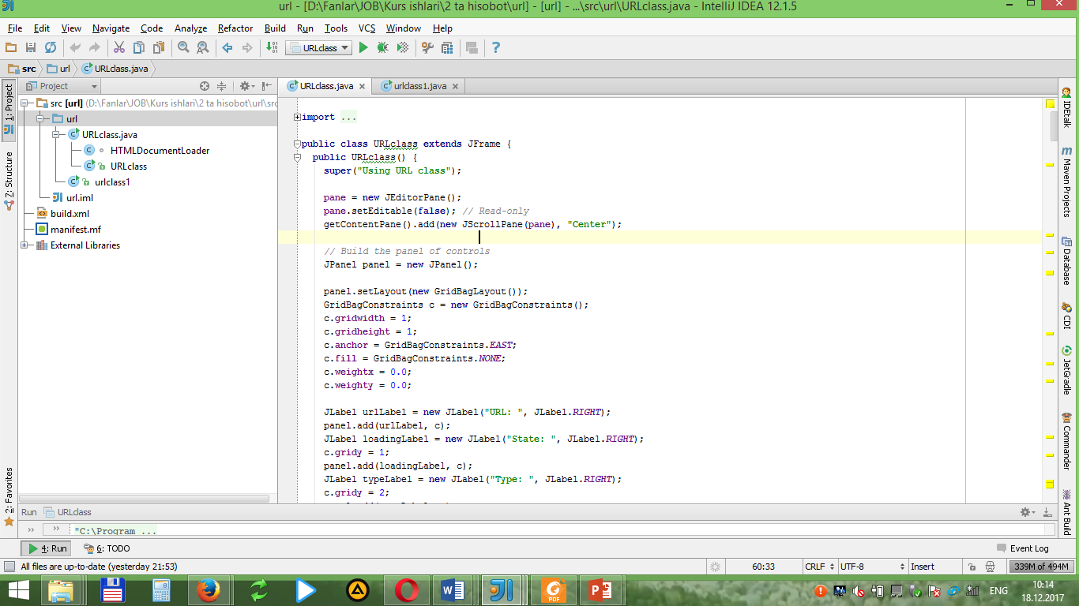
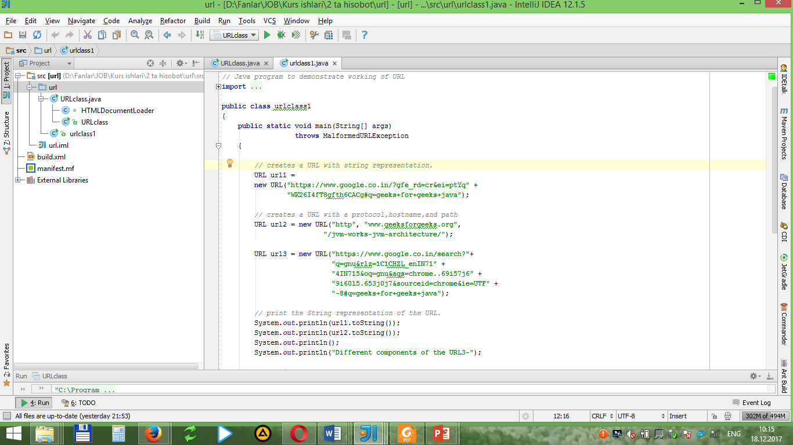

Bu klasslar tarmoq resurslari va manzilni aniqlashga qarab quyidagilarga bo'linadi:
- URI
- URL
- URLConnection
- URLStreamHandler
- HttpURLConnection
- sun.net.www.protocol.http.HttpURLConnection
- sun.net.www.http.HttpClient
- HttpURLConnection
Endi ushbu hosil qilingan ikkita klasslarga kod yozish jarayoni boshlasak bo’ladi.
import java.io.BufferedReader;
import java.net.HttpURLConnection;
import java.net.ServerSocket;
import java.net.Socket;
import java.net.URL;
4. Dastur kodi va olingan natija
URLclass uchun kod:
import java.awt.Color;
import java.awt.Cursor;
import java.awt.Dimension;
import java.awt.GridBagConstraints;
import java.awt.GridBagLayout;
import java.awt.Rectangle;
import java.awt.event.ActionEvent;
import java.awt.event.ActionListener;
import java.awt.event.WindowAdapter;
import java.awt.event.WindowEvent;
import java.beans.PropertyChangeEvent;
import java.beans.PropertyChangeListener;
import java.io.IOException;
import java.io.InputStream;
import java.io.InputStreamReader;
import java.io.Reader;
import java.net.MalformedURLException;
import java.net.URL;
import java.net.URLConnection;
import java.util.StringTokenizer;
import java.util.Vector;
import javax.swing.DefaultComboBoxModel;
import javax.swing.JCheckBox;
import javax.swing.JComboBox;
import javax.swing.JEditorPane;
import javax.swing.JFrame;
import javax.swing.JLabel;
import javax.swing.JOptionPane;
import javax.swing.JPanel;
import javax.swing.JScrollPane;
import javax.swing.JTree;
import javax.swing.UIManager;
import javax.swing.event.TreeSelectionEvent;
import javax.swing.event.TreeSelectionListener;
import javax.swing.text.AttributeSet;
import javax.swing.text.BadLocationException;
import javax.swing.text.ChangedCharSetException;
import javax.swing.text.Document;
import javax.swing.text.Element;
import javax.swing.text.ElementIterator;
import javax.swing.text.StyleConstants;
import javax.swing.text.html.HTML;
import javax.swing.text.html.HTMLDocument;
import javax.swing.text.html.HTMLEditorKit;
import javax.swing.tree.DefaultMutableTreeNode;
import javax.swing.tree.DefaultTreeModel;
import javax.swing.tree.TreeModel;
import javax.swing.tree.TreeNode;
import javax.swing.tree.TreePath; public class URLclass extends JFrame {
public URLclass() {
super("Using URL class");
pane = new JEditorPane();
pane.setEditable(false); // Read-only
getContentPane().add(new JScrollPane(pane), "Center");
JPanel panel = new JPanel();
panel.setLayout(new GridBagLayout());
GridBagConstraints c = new GridBagConstraints();
c.gridwidth = 1;
c.gridheight = 1;
c.anchor = GridBagConstraints.EAST;
c.fill = GridBagConstraints.NONE;
c.weightx = 0.0;
c.weighty = 0.0;
JLabel urlLabel = new JLabel("URL: ", JLabel.RIGHT);
panel.add(urlLabel, c);
JLabel loadingLabel = new JLabel("State: ", JLabel.RIGHT);
c.gridy = 1;
panel.add(loadingLabel, c);
JLabel typeLabel = new JLabel("Type: ", JLabel.RIGHT);
c.gridy = 2;
panel.add(typeLabel, c);
c.gridy = 3;
panel.add(new JLabel(LOAD_TIME), c);
c.gridy = 4;
c.gridwidth = 2;
c.weightx = 1.0;
c.anchor = GridBagConstraints.WEST;
onlineLoad = new JCheckBox("Online Load");
panel.add(onlineLoad, c);
onlineLoad.setSelected(true);
onlineLoad.setForeground(typeLabel.getForeground());
c.gridx = 1;
c.gridy = 0;
c.anchor = GridBagConstraints.EAST;
c.fill = GridBagConstraints.HORIZONTAL;
urlCombo = new JComboBox();
panel.add(urlCombo, c);
urlCombo.setEditable(true);
loadingState = new JLabel(spaces, JLabel.LEFT);
loadingState.setForeground(Color.black);
c.gridy = 1;
panel.add(loadingState, c);
loadedType = new JLabel(spaces, JLabel.LEFT);
loadedType.setForeground(Color.black);
c.gridy = 2;
panel.add(loadedType, c);
timeLabel = new JLabel("");
c.gridy = 3;
panel.add(timeLabel, c);
getContentPane().add(panel, "South");
DefaultMutableTreeNode emptyRootNode = new DefaultMutableTreeNode(
"Empty");
emptyModel = new DefaultTreeModel(emptyRootNode);
tree = new JTree(emptyModel);
tree.setPreferredSize(new Dimension(200, 200));
getContentPane().add(new JScrollPane(tree), "East");
urlCombo.addActionListener(new ActionListener() {
public void actionPerformed(ActionEvent evt) {
if (populatingCombo == true) {
return;
}
Object selection = urlCombo.getSelectedItem();
try {
URL url;
if (selection instanceof URL) {
url = (URL) selection;
} else {
url = new URL((String) selection);
} URL loadedURL = pane.getPage();
if (loadedURL != null && loadedURL.sameFile(url)) {
return;
}
urlCombo.setEnabled(false); // Disable input
urlCombo.paintImmediately(0, 0, urlCombo.getSize().width,
urlCombo.getSize().height);
setCursor(Cursor.getPredefinedCursor(Cursor.WAIT_CURSOR));
// Busy cursor
loadingState.setText("Loading...");
loadingState.paintImmediately(0, 0,
loadingState.getSize().width, loadingState
.getSize().height);
loadedType.setText("");
loadedType.paintImmediately(0, 0,
loadedType.getSize().width,
loadedType.getSize().height);
timeLabel.setText("");
timeLabel.paintImmediately(0, 0, timeLabel.getSize().width,
timeLabel.getSize().height);
tree.setModel(emptyModel);
tree.paintImmediately(0, 0, tree.getSize().width, tree
.getSize().height);
startTime = System.currentTimeMillis();
if (onlineLoad.isSelected()) {
pane.setPage(url);
loadedType.setText(pane.getContentType());
} else {
pane.setContentType("text/html");
loadedType.setText(pane.getContentType());
if (loader == null) {
loader = new HTMLDocumentLoader();
}
HTMLDocument doc = loader.loadDocument(url);
loadComplete();
pane.setDocument(doc);
displayLoadTime();
populateCombo(findLinks(doc, null));
TreeNode node = buildHeadingTree(doc);
tree.setModel(new DefaultTreeModel(node));
enableInput();
}
} catch (Exception e) {
System.out.println(e);
JOptionPane.showMessageDialog(pane, new String[] {
"Unable to open file", selection.toString() },
"File Open Error", JOptionPane.ERROR_MESSAGE);
loadingState.setText("Failed");
enableInput();
}} });
pane.addPropertyChangeListener(new PropertyChangeListener() {
public void propertyChange(PropertyChangeEvent evt) {
if (evt.getPropertyName().equals("page")) {
loadComplete();
displayLoadTime();
populateCombo(findLinks(pane.getDocument(), null));
TreeNode node = buildHeadingTree(pane.getDocument());
tree.setModel(new DefaultTreeModel(node));
enableInput();
}}});
tree.addTreeSelectionListener(new TreeSelectionListener() {
public void valueChanged(TreeSelectionEvent evt) {
TreePath path = evt.getNewLeadSelectionPath();
if (path != null) {
DefaultMutableTreeNode node = (DefaultMutableTreeNode) path
.getLastPathComponent();
Object userObject = node.getUserObject();
if (userObject instanceof Heading) {
Heading heading = (Heading) userObject;
try {
Rectangle textRect = pane.modelToView(heading
.getOffset());
textRect.y += 3 * textRect.height;
pane.scrollRectToVisible(textRect);
} catch (BadLocationException e) {
}}}} });}
public void loadComplete() {
loadingState.setText("Page loaded.");
}
public void enableInput() {
urlCombo.setEnabled(true); // Allow entry of new URL
setCursor(Cursor.getDefaultCursor());
}
public void displayLoadTime() {
double loadingTime = ((double) (System.currentTimeMillis() - startTime)) / 1000d;
timeLabel.setText(loadingTime + " seconds");
}
public void populateCombo(URL[] urls) {
Object o = urlCombo.getSelectedItem();
populatingCombo = true;
urlCombo.setModel(new DefaultComboBoxModel(urls));
urlCombo.setSelectedItem(o);
populatingCombo = false; }
public URL[] findLinks(Document doc, String protocol) {
Vector links = new Vector();
Vector urlNames = new Vector();
URL baseURL = (URL) doc.getProperty(Document.StreamDescriptionProperty);
if (doc instanceof HTMLDocument) {
Element elem = doc.getDefaultRootElement();
ElementIterator iterator = new ElementIterator(elem);
while ((elem = iterator.next()) != null) {
AttributeSet attrs = elem.getAttributes();
Object link = attrs.getAttribute(HTML.Tag.A);
if (link instanceof AttributeSet) {
Object linkAttr = ((AttributeSet) link)
.getAttribute(HTML.Attribute.HREF);
if (linkAttr instanceof String) {
try {
URL linkURL = new URL(baseURL, (String) linkAttr);
if (protocol == null
|| protocol.equalsIgnoreCase(linkURL
.getProtocol())) {
String linkURLName = linkURL.toString();
if (urlNames.contains(linkURLName) == false) {
urlNames.addElement(linkURLName);
links.addElement(linkURL);
}
}
} catch (MalformedURLException e) {
}}}} }
URL[] urls = new URL[links.size()];
links.copyInto(urls);
links.removeAllElements();
urlNames.removeAllElements();
return urls;
}
public TreeNode buildHeadingTree(Document doc) {
String title = (String) doc.getProperty(Document.TitleProperty);
if (title == null) {
title = "[No title]";
}
Heading rootHeading = new Heading(title, 0, 0);
DefaultMutableTreeNode rootNode = new DefaultMutableTreeNode(
rootHeading);
DefaultMutableTreeNode lastNode[] = new DefaultMutableTreeNode[7];
int lastLevel = 0;
lastNode[lastLevel] = rootNode;
if (doc instanceof HTMLDocument) {
Element elem = doc.getDefaultRootElement();
ElementIterator iterator = new ElementIterator(elem);
Heading heading;
while ((heading = getNextHeading(doc, iterator)) != null) {
DefaultMutableTreeNode hNode = new DefaultMutableTreeNode(
heading);
int level = heading.getLevel();
if (level > lastLevel) {
for (int i = lastLevel + 1; i < level; i++) {
lastNode[i] = null;
}
lastNode[lastLevel].add(hNode);
} else {
int prevLevel = level - 1;
while (prevLevel >= 0) {
if (lastNode[prevLevel] != null) {
break;
}
lastNode[prevLevel] = null;
prevLevel--;
}
lastNode[prevLevel].add(hNode);
}
lastNode[level] = hNode;
lastLevel = level;
} }
return rootNode;}
public Heading getNextHeading(Document doc, ElementIterator iter) {
Element elem;
while ((elem = iter.next()) != null) {
AttributeSet attrs = elem.getAttributes();
Object type = attrs.getAttribute(StyleConstants.NameAttribute);
int level = getHeadingLevel(type);
if (level > 0) {
String headingText = "";
int count = elem.getElementCount();
for (int i = 0; i < count; i++) {
Element child = elem.getElement(i);
AttributeSet cattrs = child.getAttributes();
if (cattrs.getAttribute(StyleConstants.NameAttribute) == HTML.Tag.CONTENT) {
try {
int offset = child.getStartOffset();
headingText += doc.getText(offset, child
.getEndOffset()
- offset);
} catch (BadLocationException e) {
}} }
headingText = headingText.trim();
return new Heading(headingText, level, elem.getStartOffset());
} }
return null;
}
public int getHeadingLevel(Object type) {
if (type instanceof HTML.Tag) {
if (type == HTML.Tag.H1) {
return 1; }
if (type == HTML.Tag.H2) {
return 2; }
if (type == HTML.Tag.H3) {
return 3; }
if (type == HTML.Tag.H4) {
return 4; }
if (type == HTML.Tag.H5) {
return 5; }
if (type == HTML.Tag.H6) {
return 6; }}
return -1;}
static class Heading {
public Heading(String text, int level, int offset) {
this.text = text;
this.level = level;
this.offset = offset;}
public String getText() {
return text;
}
public int getOffset() {
return offset; }
public int getLevel() {
return level;}
public String toString() {
return text; }
protected String text;
protected int level;
protected int offset;}
public static void main(String[] args) {
try {
UIManager.setLookAndFeel("com.sun.java.swing.plaf.windows.WindowsLookAndFeel");
} catch (Exception evt) {}
JFrame f = new URLclass();
f.addWindowListener(new WindowAdapter() {
public void windowClosing(WindowEvent evt) {
System.exit(0);
}});
f.setSize(500, 400);
f.setVisible(true);}
private static final String spaces = " ";
private static final String LOAD_TIME = "Load time: ";
private JEditorPane pane;
private HTMLDocumentLoader loader;
private JLabel loadingState;
private JLabel timeLabel;
private JLabel loadedType;
private JCheckBox onlineLoad;
private JComboBox urlCombo;
private JTree tree;
private TreeModel emptyModel;
private long startTime;
private boolean populatingCombo;
}
class HTMLDocumentLoader {
public HTMLDocument loadDocument(HTMLDocument doc, URL url, String charSet)
throws IOException {
doc.putProperty(Document.StreamDescriptionProperty, url);
InputStream in = null;
boolean ignoreCharSet = false;
for (;;) {
try {
doc.remove(0, doc.getLength());
URLConnection urlc = url.openConnection();
in = urlc.getInputStream();
Reader reader = (charSet == null) ? new InputStreamReader(in)
: new InputStreamReader(in, charSet);
HTMLEditorKit.Parser parser = getParser();
HTMLEditorKit.ParserCallback htmlReader = getParserCallback(doc);
parser.parse(reader, htmlReader, ignoreCharSet);
htmlReader.flush();
break;
} catch (BadLocationException ex) {
throw new IOException(ex.getMessage());
} catch (ChangedCharSetException e) {
charSet = getNewCharSet(e);
ignoreCharSet = true;
in.close(); } }
return doc;
} public HTMLDocument loadDocument(URL url, String charSet)
throws IOException {
return loadDocument((HTMLDocument) kit.createDefaultDocument(), url,
charSet);
} public HTMLDocument loadDocument(URL url) throws IOException {
return loadDocument(url, null);
} // Methods that allow customization of the parser and the callback
public synchronized HTMLEditorKit.Parser getParser() {
if (parser == null) {
try {
Class c = Class
.forName("javax.swing.text.html.parser.ParserDelegator");
parser = (HTMLEditorKit.Parser) c.newInstance();
} catch (Throwable e) {
}}
return parser;
} public synchronized HTMLEditorKit.ParserCallback getParserCallback(
HTMLDocument doc) {
return doc.getReader(0);
} protected String getNewCharSet(ChangedCharSetException e) {
String spec = e.getCharSetSpec();
if (e.keyEqualsCharSet()) {

return spec;
}
int index = spec.indexOf(";");
if (index != -1) {
spec = spec.substring(index + 1);
}
spec = spec.toLowerCase(); StringTokenizer st = new StringTokenizer(spec, " \t=", true);
boolean foundCharSet = false;
boolean foundEquals = false;
while (st.hasMoreTokens()) {
String token = st.nextToken();
if (token.equals(" ") || token.equals("\t")) {
continue;
}
if (foundCharSet == false && foundEquals == false
&& token.equals("charset")) {
foundCharSet = true;
continue;
} else if (foundEquals == false && token.equals("=")) {
foundEquals = true;
continue;
} else if (foundEquals == true && foundCharSet == true) {
return token;
} foundCharSet = false;
foundEquals = false;
}
return "8859_1";
} protected static HTMLEditorKit kit; protected static HTMLEditorKit.Parser parser; static {
kit = new HTMLEditorKit();
}
}

urlclass1 uchun kod
import java.net.MalformedURLException;
import java.net.URL;

public class urlclass1
{
public static void main(String[] args)
throws MalformedURLException
{

// creates a URL with string representation.
URL url1 =
new URL("https://www.google.co.in/?gfe_rd=cr&ei=ptYq" +
"WK26I4fT8gfth6CACg#q=geeks+for+geeks+java");

// creates a URL with a protocol,hostname,and path
URL url2 = new URL("http", "www.geeksforgeeks.org",
"/jvm-works-jvm-architecture/");

URL url3 = new URL("https://www.google.co.in/search?"+
"q=gnu&rlz=1C1CHZL_enIN71" +
"4IN715&oq=gnu&aqs=chrome..69i57j6" +
"9i60l5.653j0j7&sourceid=chrome&ie=UTF" +
"-8#q=geeks+for+geeks+java");

// print the String representation of the URL.
System.out.println(url1.toString());
System.out.println(url2.toString());
System.out.println();
System.out.println("Different components of the URL3-");

// retrieve the protocol for the URL
System.out.println("Protocol:- " + url3.getProtocol());

// retrieve the hostname of the url
System.out.println("Hostname:- " + url3.getHost());

// retrieve the defalut port
System.out.println("Default port:- " +
url3.getDefaultPort());

// retrieve the query part of URL
System.out.println("Query:- " + url3.getQuery());

// retrive the path of URL
System.out.println("Path:- " + url3.getPath());

// retrive the file name
System.out.println("File:- " + url3.getFile());

// retrieve the reference
System.out.println("Reference:- " + url3.getRef());
}
}

Olingan natijalar:

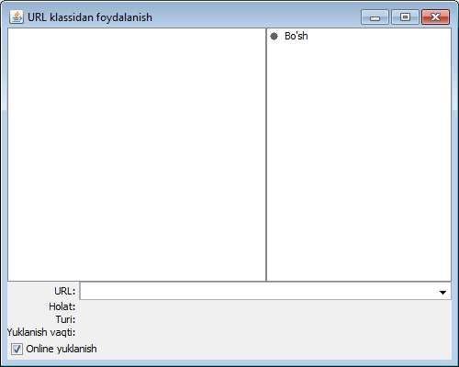
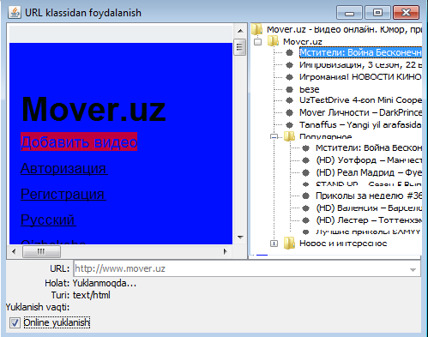

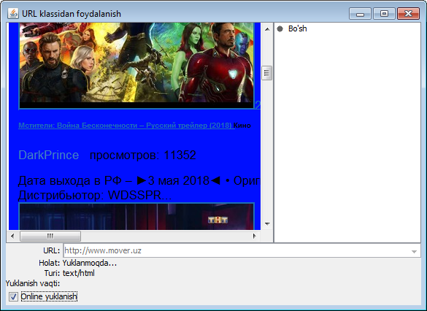

Ushbu Amaliy ishida klient server arxitekturasiga asoslangan Urlconnection tizimi uchun soketli dasturlashdan foydalanib tarmoq ilovasini yaratish maqsad qilib qo’yilgan edi.

Java IntellijIdea interfeysidan foydalanib klient uchun alohida klass va server uchun alohida klass yaratilib maqsadga erishildi.
URLConnection barcha klasslarning superklassi hisoblanib, URL orqali aniqlangan tarmoq resurslari va ilovalar o'rtasida aloqa o'rnatadi.
URL instance resurs joylashgan manzilni taqdim etish uchun ishlatiladi hamda URL connection instance resurs joylashgan joy bilan chiqish aloqasini o'rnatish uchun kanalni taqdim etish uchun ishlatiladi. Bugungi kunda eng ko'p qo'llaniladigan URLConnection bu – HttpURLConnection.
Bu klass handler deb nomlanadi. U URLStreamHandler klassini imkoniyatlarini kengaytiradi. Uning asosiy vazifasi protokol nomini (crypt) paket nomiga o'zgartirishdir. Ya'ni, crypt protokoli asosida URL yaratilganida, Java virtual mashinasida ham URLStreamHandler crypt protokolining misoli yaratiladi. Handler ikki xil vazifani amalga oshiradi: URL string ni yaratishga ko'maklashadi hamda xost bilan ochiq aloqa o'rnatish vaqti kelganida, CryptURLConnection ob'ektini yaratadi.
Shunday qilib URL bu – so’ralayotgan hujjatning aniq adrеsini ko’rsatish imkoniyatini bеrish uchun www.mail.ru kabi adrеslar turlari kombinatsiyasi va yana qo’shimcha elеmеntlarga ega. URL day foydalanib, wеb-brauzеrlar yordamida ixtiyoriy hujjat va xizmatlarga dostup olish mumkin. URL quyidagi tartibda yoziladi:
Protokol://intеrnеt_adrеs /yo’l /fayl_nomi.kеngaytma yoki Protokol://intеrnеt_adrеs URL ga misol: http://www.microsoft.com/windows/index.html

Xulosa o’rnida aytadigan bo’lsak, urlconnection uchun browserning localhost nomi va uning ip adresi shuningdek uning port nomi ulanganligi haqidagi ma’lumot ekranga chiqadi.
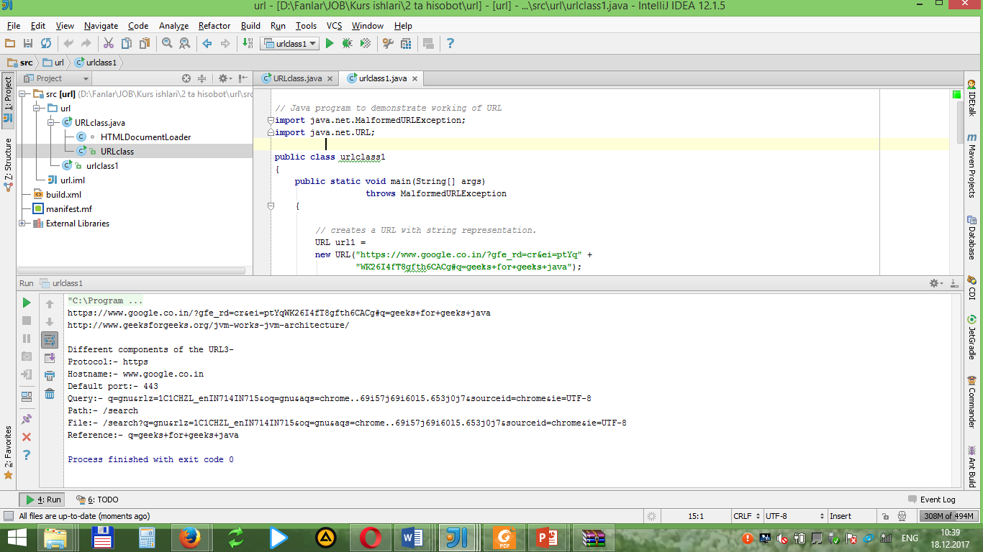

Talabalarga topshiriq.
Har bir talaba o’zining tartib raqamiga mos variantni bajarishi lozim. Bunda quyidagi jadvalda keltirilgan sayt havolalaridan bir tanlanadi va URLConnection klassidan foydalangan holda ushbu sayt tahlil qilinishi va natijalardan skrinshot olinib hisobot shakllantirilishi lozim.

№ | URL manzil | № | URL manzil
 | asilmedia.uz |  | realblancos.uz
 | qnb.uz |  | xabardor.uz
 | daxshat.uz |  | daryo.uz
 | kun.uz |  | tuit.uz
 | mytube.uz |  | samtuit.uz
 | nnmuz.com |  | ucell.uz
 | zver.uz |  | olx.uz
 | soundplanet.uz |  | mover.uz
 | dump.uz |  | uzdtv.uz
 | file.dodasi.uz |  | topmusic.uz

